Example Design: Session Management by Trade Server Design

Overview

Current processing
Currently if there is a problem with any one hybrid trade server in the start/stop session we have to restart the whole session that affects the classes on the boxes which are already fine.

New requirement
To avoid the above problem, this feature will allow us to start/stop session, EOD and do EOD purge for a given session on a given trade server/s. This feature will also give the more diagnostic type capablility, to monitor the status of session event on a trade server basis when the overall trading session event is pending.

Implementation

Server registration with TSS.
Currently trade server registration with TSS is session less, now trade server will register with the supported sessions. TSS will maintain/persist this information.
- Once a server is registered for a session with TSS this info will be there until manually deleted.
- If server does not register with session, that server will be registered for each and every session. This will avoid the rollout issues we may have when not all trade servers are rolled out.
- If there is a trader refrence for any registered server but it does not exists in TSSRegistrationMap that trader entry will not get any trading session events.
- Once a server is registered with TSS and later on (as part of failover on B side, which is not yet rolled out) trade server registeres with old method(without session) that server will not be registered for all the sessions.
- Support a admin request to dump the in memory registration map.

Trading Session Event History.
When a trading session event is fired for sessoin, Global server will publish an event which will contain the state of trading session event along with event state of all the servers registered for that session. As and when servers complete the event Global will publish incremental update for event history and this event will contain only one trade server and its status. This same event will be used by GUI to update the “trading session event snapshot for servers” window.
When session event is started on only one server(or set of servers) the first event will contain only those servers for which request was made, instead of including all the servers for session.
  - Trading session event status is success when ALL the target servers are successful.
  - Trading session event status is ‘failed’ when ALL the target servers are NOT successful. so if one trade server, which is part of session, is down event status for this trade server will be NOT_AVAIL that will result the status of overall event to be FAILED, though event processing will be successful on other servers.
  - If one server returns exception/error, during any trading session event(‘preapre start session’) next intended event of parent event(‘start session’) will continue on the other servers and will exclude the server which had problems.
  - Every time event history is published for ‘all servers’ it will be a double publish (old and new struct) and will be controlled by xml switch.
  - history details will be kept only for 3 bus day, history entries will be unchanged.

TradingSessionRegistrationMapHome.
This home will be responsible to maintain the registration of server for session. Explain what ever details you want to .
- void registerServer(string sessionName, string serverName) throws AuthorizationException, SystemException, CommunicationException, DataValidationException, TransactionFailedException.
- void updateServerState(string sessionName, string serverName, boolean isActive) throws AuthorizationException, SystemException, CommunicationException, DataValidationException, TransactionFailedException
- RegisteredServerNameSequence getServersForSession(string sessionName) throws AuthorizationException, SystemException, CommunicationException, DataValidationException
- boolean validateServerRegistration(string sessionName, string serverName) throws AuthorizationException, SystemException, CommunicationException, DataValidationException, TransactionFailedException
- long updateLastEventStateForServer(string sessionName, string serverName, short eventType, short eventState, short eventGroup) throws AuthorizationException, SystemException, CommunicationException, DataValidationException, TransactionFailedException
- TradingSessionServerEventStateStructSequence getServerEventStates(string sessionName) throws AuthorizationException, SystemException, CommunicationException, DataValidationException, TransactionFailedException

TradingSessionEventHistoryHome.
- convertToV2Struct(TradingSessionEventHistoryEntry histEntry)

Scripts(2)
- ar and wrapper scripts for start/endSession, EOD and EOD purge for groups.
- startServer for new homes
- template scripts for new xmls
- find out list of all the scripts affected by this change.
- endSession/endOfDay/endOfDayPurge will have another flag for abortOnFirstError.
- new parameter for server names

Database(.5)
- TradingSessionRegistrationMap
- TradingSessionEventHistDetail

SetContext(.125)
- None

XML/DTD(.5)
- TradingSessionRegistrationMapHome.xml/dtd
- XML re-genration required

Homes/Services(4)
- TradingSessionRegistrationMapHome
- TradingSessionEventHistoryHome
- TradingSessionEventHistoryEntry
- TradingSessionEventHisttoryDetailImpl

ImplPlan(.5)
- GC will be rolled out first and then BC’s
- GCB should also be rolled out before any BC is rolled out to handle GC failover.
- Event History will need to be double published, with xml switch.
- IMP - As part of GCA rollout all the tradeeng processes will need to be restarted.
- For any BC rollout, corresponding entry in tradingSessionRegistrationMap table will need to be deleted for all the sessions.

PerformanceTestingProcedure(1)
- List all scenariois here.

TestingProcedure(1)
- List all scenariois here.

OperatorProcedure(.5)
- Describe how to start/end session, EOD/purge on desired trade servers.

Fallback/Failover
- List how fallback/failover will be achieved after rollout.

GUI Overview
The users would like to Open, Start End Of Session, and Start End Of Day, targeted to a specific session and trade server. Currently, they can perform this on the scope of only session. This will require changes to the Trading Session Management screen. While we are modifying this screen, we should make additional changes to areas that have usability issues.

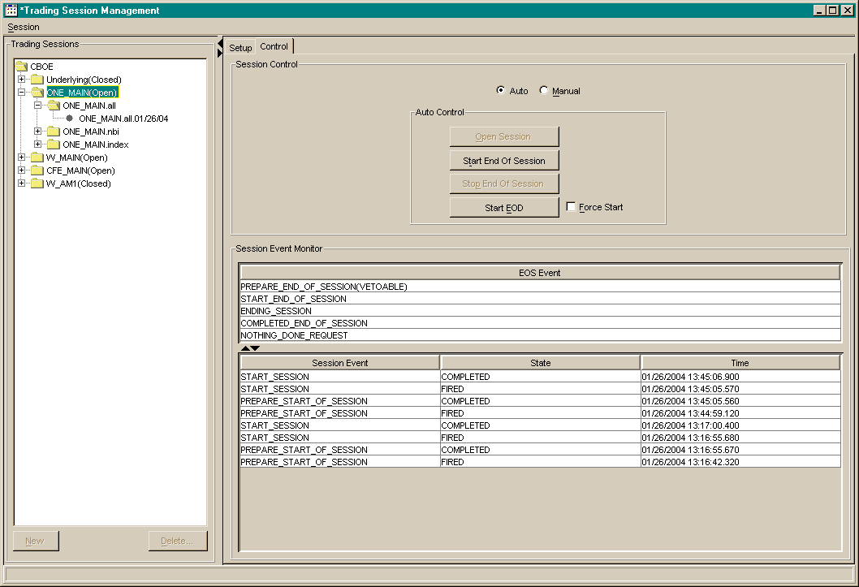

The user needs to be able to select specific Trade Servers to perform the Open Session, Start End Of Session, and Start EOD actions on. The events for the EOS table will be merged into one table with the history. We will be getting many additional events from the event channel for individual trade servers now.

Trade Server State
The list of Trade Servers for each session will also display the last state it was in and change state as we get further events.

